Who were the first women mathematicians and how did they impact the field?

By Ivan Novasak

Southern New Hampshire University

MAT 450 - History of Mathematics / Mathematics Education

For Toke Knudsen

2023 June 18

# Who were the first women mathematicians and how did they impact the field?

Pandrosion and Hypatia, being the two known women mathematician pioneers, paved the way for showing society that one does not need to be a man to achieve greatness in STEM. Though little is known about Pandrosion, she still deserves the honour of first female mathematician. Hypatia is the woman who was historically credited as the first female mathematician, to the point of having events named after her in the 21st Century.

# Pandrosion

**Introduction**

Pandrosion was a Greek mathematician / maths teacher believed to have been born in Alexandria in circa 300 CE and died circa 360 CE. She is mentioned in Pappus’ 3rd book of an 8-book series and Pappus (b 290, d 350) was of that time period of the first half of the 4th century CE. (O’Connor & Robertson, 2018a / 1999)

**Original Confusion Over Her Gender**

There was confusion for over 300 years on whether Pandrosion was male or female. Scholars originally assumed she was male due to pro-male bias in STEM and universities in general but ignored that Pappus always used the feminine suffix ‘ion’ to refer to her. In 1988 scholars re-translated Pappus’ work and this time did not make any assumptions. Her name was actually Pandrosos which was named after the daughter of Cecrops and Aglauros in Greek mythology. So her name is a fully female name and the ‘ion’ suffix is also a feminine suffix in ancient Greek. (O’Connor & Robertson, 2018b / Holladay, 2023)

**Mathematical Contributions & Criticism By Pappus**

The main accomplishment Pandrosion is known for is an approximate method for doubling cubes. A method for finding cube roots she pioneered was not without criticism, as Pappus took issue with it in a pedantic way that involved difference between problem and theorem. Pappus also took issue with her method for finding arithmetic/geometric/harmonic means in a semicircle, even though mathematical scholars of our times accept Pandrosion’s then new methods both of calculating the semicircle’s mean and cube roots as valid. Scholars theorise that Pandrosion received this criticism from Pappus but due to gender difference but due to academic rivalries. (O’Connor & Robertson, 2018a/c)

**Legacy**

Little is known about Pandrosion’s immediate legacy in the centuries that directly followed her death given that other mathematical scholars of the 5th/6th Centuries as well as in other regions of the world following this timeframe didn't reference her in their work. She did grow up a couple generations prior to Hypatia in the same region and so there is a possibility she influenced Hypatia. (O’Connor & Robertson, 2018c) Pandrosion’s long-term legacy can be more focused on what majority bias - be it gender or race - does to the legacy of people who contribute great things in society. This bias is something we all still are dealing with and are trying to stamp out these days in the 21st Century.

**Hypatia**

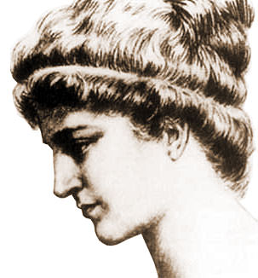

***Sketch by Elbert Hubbard from 1908 (Hubbard, 2012)***

**Birth, upbringing, and personal life**

Hypatia was born circa 350–370 CE in Alexandria, Egypt and was the daughter of Theon, also of Alexandria, who was a mathematician and astronomer that was famous for writing a student edition of *Elements* by Euclid. Hypatia spoke Greek which was the language of the educated people there at the time. Like her father Theon, who ran the Mouseion Neoplatonist philosophy academy, Hypatia became a mathematician, philosopher, and astronomer. Hypatia taught the 3 above subjects and was believed to have also taught practical science because one of her students, Synesius, requested by letter that Hypatia send him a hydrometer (a device used to measure density of liquids by way of buoyancy), as well as another letter from the same student involving being taught how to make an astrolabe. (*Famous Scientists*, 2018)

Hypatia was appreciated and got lots of respect due to both her work in philosophy as well as her looks. She was said to have looks that grabbed a lot of men’s attention at the time, yet scholars believe she had no interest in pairing up with anyone and remained celebate her whole life. One particular incident is reported regarding her rejecting a man’s advances via showing him a used menstrual handkerchief which sent him away and showed how such relations were viewed as impure. This sticking to chastity and being publicly known as being chaste alongside her academic work earned her even more respect for in Greek society they highly valued celibacy. (Chrysopoulos, 2023)

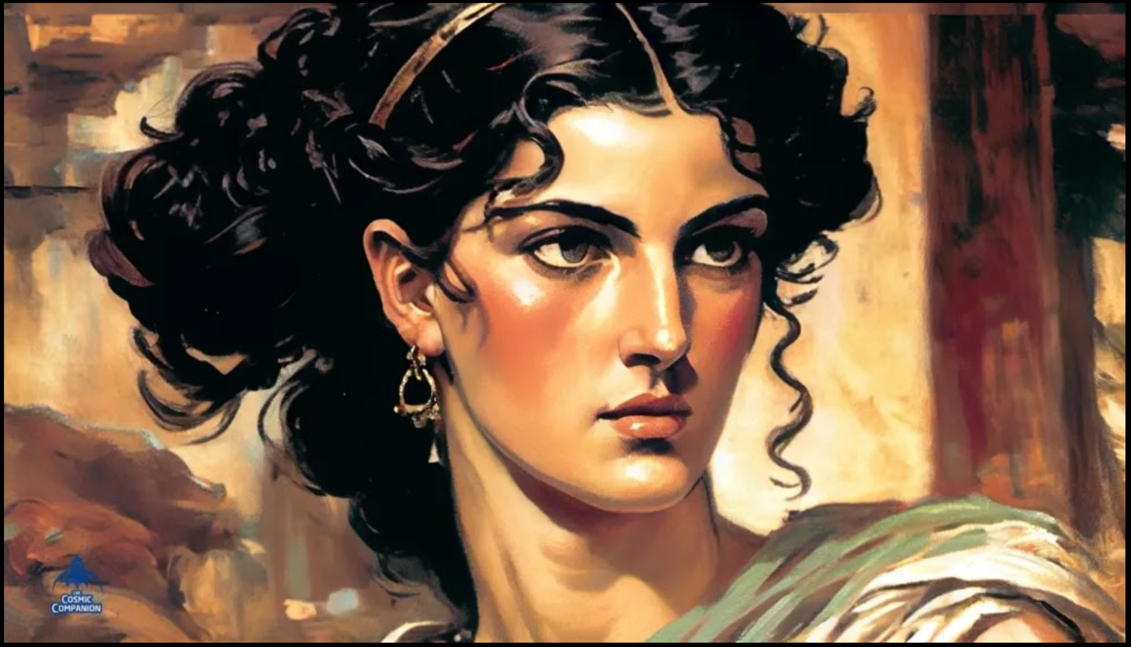

***AI-based rendering by way of Chat-GPT & Midjourney (Cosmic Companion, 2023)***

**Career/works**

Hypatia is one of the first known women in STEM to be what we today call a feminist - a woman who stands up for her right to be treated as equal in society. She is so well regarded in feminist circles that the most prominent feminist philosophy journal, which began in 1983, is named after her. Her main accomplishments that scholars are aware of were 13 volumes of commentary on *Arithmetica* by Diaphantus, an 8-volume commentary on *Treatise on the Conics of Apollonius* where she made difficult concepts like the ellipse and parabola accessible to students (which tied into her background on astronomy, as well), as well as contributions to Book III of Ptolemy's *Almagest*. Hypatia’s work on conic sections would be the final known written work on conic sections all the way up until the 17th Century. Hypatia is known for both firsts and lasts in history, being both the first well-known female mathematician and STEM educator. She was also the last great pagan (non-Christian) scientist and Greek mathematician as Alexandria fell at a time when no major inroads for Western mathematical progress would be made for around a millennium. (Bily, 2023)

**Death**

In March of 415 CE, Hypatia was murdered in a most gruesome of ways (torture and cut up then burning of body) by a Christian mob believed to be at the command of Cyril, the relatively new leader of Alexandria at the time. The same people are believed to have assaulted Hypatia’s friend Orestes, who had a dispute with Cyril. (Viney, 2013) During the time Hypatia was murdered, traditional religions were being displaced by the then up-and-coming Christianity, which was still developing out of traditional Judaism. Hypatia did not want to convert to Christianity and instead wanted to remain pagan as she had been her whole life. Scholars believe that Cyril, the bishop of Alexandria, accused Hypatia of worshipping idols, which charge modern scholars believe was politically motivated. (Chrysopoulos, 2023)

**Hypatia’s Legacy & Her Impacts on STEM**

Hypatia has a long legacy that continues to stretch forever into the future, and has paved the way for further achievements by other women in the many centuries since her pioneering accomplishments. This legacy extends both within mathematical developments as well as the wider world of women and girls in STEM.

**Women in STEM**

In 1678, Elena Lucrezia Cornaro Piscopia became the first ever woman to earn a PhD. She also lectured in mathematics at the University of Padua later in 1678 and later on was a member of other European academies. Maria Agnesi was the first woman to write a mathematics textbook when she wrote *The Analytical Institutions* in 1748, which brought calculus to a much wider audience. She also has another work called ‘Witch of Agnesi’, which combines calculus and analytic geometry together. Another woman who wasn’t allowed to be officially enrolled at university for a PhD programme due to her gender yet still was awarded one is Sofia Kovalevskaya. She attended Göttingen University and was awarded her PhD in 1874 - at least 6 years before they started formally allowing women to study there. Given that she wasn’t formally enrolled at the university, she needed to ask special permission from each professor to take each course in the programme. Despite this challenge (as well as any other challenges of being the only female enrolled), she went on to be awarded the Prix Bordin in 1888 for her work in analysis, mechanics, and partial differential equations. By the time she died in 1891, she had published 10 papers, served as chair for a European university, and was awarded a prize from the Swedish Academy of Sciences.

Olga Ladyzhenskaya was born and raised in Stalinist Russia where many intellectuals were considered enemies of the state and her father was arrested and executed without a trial. Ladyzhenskaya had done research in partial differential equations and fluid dynamics which the government was so impressed with that despite their policies, they allowed her to be exempt from required lectures so she could attend mathematical seminars. Her big accomplishment involved a breakthrough in the Navier-Stokes equations, which describe the relationships between velocity, pressure, temperature, and the density of moving fluids. In 2002, she was awarded the Lomonosov Gold Medal and over her lifetime authored over 200 scientific publications.

So far, there has been only 1 woman to earn the most prestigious prize of the Fields Medal: Maryam Mirzakhani, who was awarded it in 2014 for her work in Riemann surfaces and moduli spaces. She was from Iran, a country with deep segregation of gender roles, yet she was flying high in her studies at a special all-girls’ school for gifted students as far back as age 17 when she won Gold in the Iran Mathematics Olympiad. Maryam Mirzakhani’s work is a direct connection from the days of Hypatia and her work more than 1600 years prior in conics, geometry, and astronomy to the present day. (Wachtel, 2023)

**Education**

Hypatia Day at Saint Mary’s College on 2017 February 18 was an all-day conference for girls in grade 7 (age 11–13) as well as their parents for encouraging them to get into STEM careers, as well as being mentored by STEM women who are in college and high school. There were also parent educational sessions on supporting their daughters in their career plans, as well as the financial preparation for college. (Saint Mary’s College, 2017)

Black Girls CODE (BGC) is an organisation that was formed in 2011 by Kimberly Bryant that allows young girls ages 7 to 17 to get involved in computer programming in a safe, progressive environment via after-school activities, summer camps, as well as community partnership events. All coding ability levels are accepted from novice to advanced/experts. Types of coding include web design, game/mobile apps, and robotics. Some of the curricula and interview videos can be viewed at <<https://wearebgc.org/codealong/>>. (Black Girls CODE, 2023)

**Concluding Remarks**

**Reflection**

This paper has shown how Hypatia overcame her struggles in the patriarchal world of her time. We today have similar struggles in society that require groups like Saint Mary’s College and Black Girls CODE. Hypatia’s legacy influenced women many centuries later to the present day to never give up on their dreams of working in mathematics and the sciences in general. Our work in society needs to incorporate people of all genders and backgrounds to ensure everyone can contribute meaningfully. Pandrosion’s legacy continues as well because it shows the error of scholars’ ways with having pro-male bias, a bias we as a society we all need to fight against and preserve the truth.

**Implementation in a classroom**

I believe more events like Hypatia Day at Saint Mary’s College, as well as organisations like Black Girls CODE, need to take place and exist so girls and women are encouraged from a young age to get into the sciences. Hypatia proved that science and mathematics aren’t only a thing for males way back in the 5th Century, and there is far less stopping us from developing more programmes to cater to this large demographic in our schools. It is necessary for both male and female students to have inspirational people to look up to, including in the world of STEM.

Groups like Black Girls CODE are another legacy of Hypatia because in her time, women and minorities were not viewed as worthy or even allowed to be in the sciences, but thanks to her and the long chain of other women scientists who were inspired by her, groups like Black Girls CODE can seamlessly exist and product great things in society’s next generations.

**References**

Bily, C. A. (2023). Hypatia. *Salem Press Biographical Encyclopedia*.

Black Girls CODE. (2023, May 24). *What We Do - Black Girls CODE*. <https://wearebgc.org/what-we-do/>

Chrysopoulos, P. (2023, May 3). Hypatia: The Female Greek Philosopher Killed for Her Beliefs. *GreekReporter.com*. <https://greekreporter.com/2023/05/03/hypatia-greek-philosopher/>

Cosmic Companion, The. (2023, April 10). Reconstructing Hypatia of Alexandria Using Artificial Intelligence | The Cosmic Companion. *Medium*. <https://medium.com/the-cosmic-companion/reconstructing-hypatia-of-alexandria-using-artificial-intelligence-8bd7794da52>

Holladay, J. (2023, January 24). Pandrosion: How the most ancient woman mathematician was (almost) lost in history. *Reinvented Magazine*. <https://www.reinventedmagazine.com/post/pandrosion-how-the-most-ancient-woman-mathematician-was-almost-lost-in-history>

Hubbard, E. (2012, April 26). Hypatia of Alexandria. *World History Encyclopedia*. Retrieved from <https://www.worldhistory.org/image/103/hypatia-of-alexandria/>

Hypatia - Biography, Facts and Pictures. (2018, September 10). *Famous Scientists*. <https://www.famousscientists.org/hypatia/>

O’Connor, J.J. & Robertson, E.F. (1999, April). Pappus. *Maths History*. <https://mathshistory.st-andrews.ac.uk/Biographies/Pappus/>

O’Connor, J.J. & Robertson, E.F. (2018a, May). Pandrosion. *Maths History*. <https://mathshistory.st-andrews.ac.uk/Biographies/Pandrosion/>

O’Connor, J.J. & Robertson, E.F. (2018b, May). Pandrosion - man or woman? *Maths History*. <https://mathshistory.st-andrews.ac.uk/Extras/Pandrosion_man_woman/>

O’Connor, J.J. & Robertson, E.F. (2018c, May). Pappus criticises Pandrosion. *Maths History*. <https://mathshistory.st-andrews.ac.uk/Extras/Pappus_Pandrosion/>

Saint Mary’s College. (2017, February 18). *Hypatia Day | Saint Mary’s College, Notre Dame, IN*. <https://www.saintmarys.edu/academics/departments/mathematics-computer-science/HypatiaDay>

Viney, D. W. (2013). Remembering and Misremembering Hypatia: The Lessons of “Agora.” *Midwest Quarterly*, 54(4), 352–369.

Wachtel, I. (2023, April 28). Female mathematicians throughout history overcome barriers to excel in a male-dominated field - USC Dornsife News. *USC Dornsife*. <https://dornsife.usc.edu/news/stories/female-mathematicians-throughout-history-overcome-barriers-to-excel-in-a-male-dominated-field/>